**LASSO, RIDGE & ELASTIC NET REGRESSION**

**Business Problem** = ﻿Prepare a prediction model for Predicting Price.

* **Name of the File: -** ToyotaCorolla.csv
* **Size of the File: -** 244 KB
* **Data: -** 1435 Observation, 9 Variable
* **Column Name: -** Price,Age_08_04,KM,HP,cc,Doors,Gears,Quarterly_Tax,Weight

**Exploratory data Analysis** =

* **Outliers: -**  yes outliers are presents and deleting one outlier .
* **Missing Value: -** Data don’t have Missing Values
* **Normality: -** Data are not normal
* **Transformation: -**  May be Required to improve accuracy

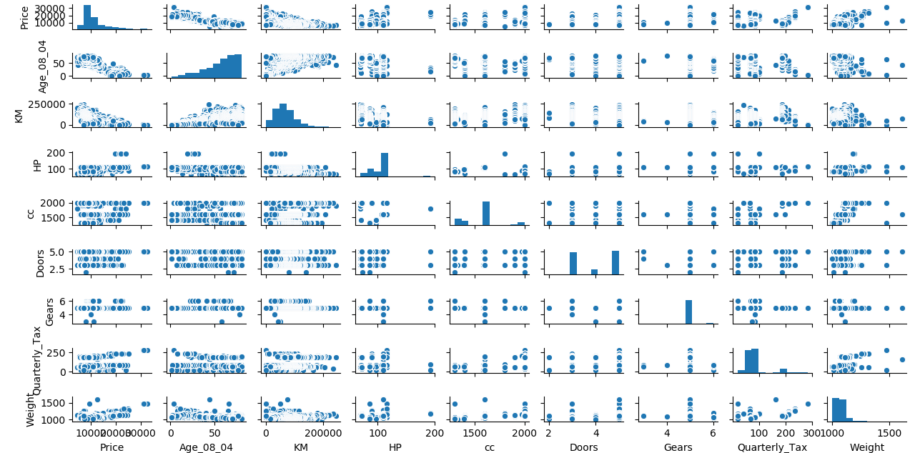**Scatter plot =** From below scatter plot we can say that Age and Price, Km and Price is having good negative correlation and rest are having weak or moderate correlation.

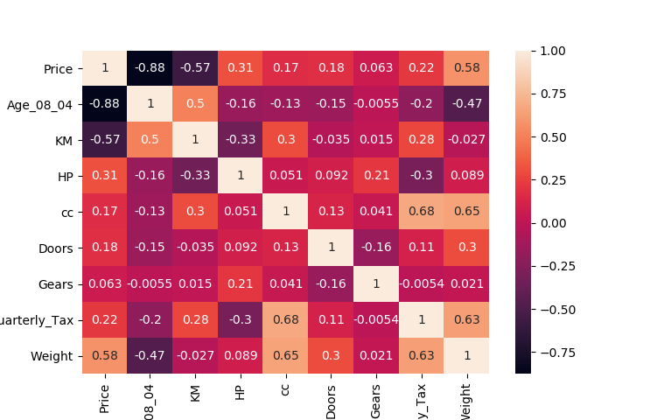

**Correlation Coefficient (r) =**  From heat map we can see that Age and price is have highest correlation and after that Km and Price is have moderate correlation and also Weight is having moderate positive correlation with price and we cannot observe any high correlation between any two input variable so it means data don’t have any collinearity problem.

**Building Lasso Model =**

* **Scatter Plot for Selection of Perfect Lambda value : -**

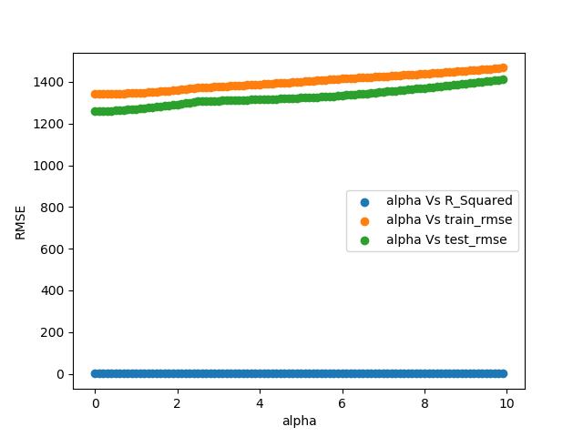

**Accuracy =** Building model by selecting optimum value of Lambda i.e. 0.01 by help of the above plot. Accuracy given by model as follows.

* **R2 : -** 87%
* **Train RMSE : -** 1342
* **Test RMSE :** - ﻿1258

**Important Coefficient Plot =**

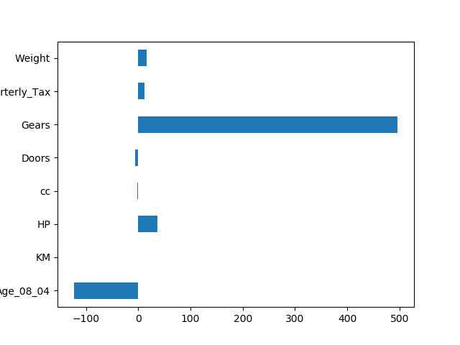

**Building Ridge Model =**

* **Scatter Plot for Selection of Perfect Lambda value : -**

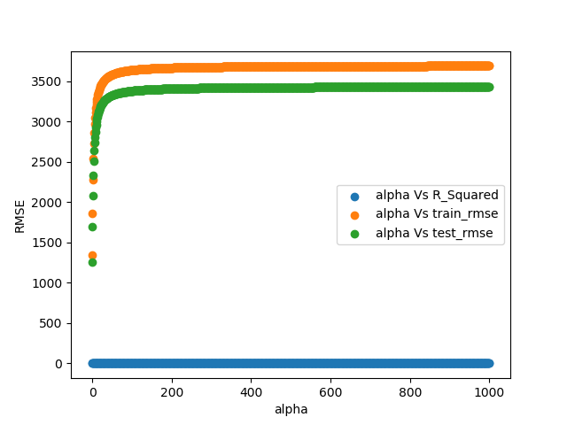

**Accuracy =** Building model by selecting optimum value of Lambda i.e. 0.01 by help of the above plot. Accuracy given by model as follows.

* **R2 : -** 87%
* **Train RMSE : -** ﻿﻿1342
* **Test RMSE :** - 1258

**Important Coefficient Plot =**

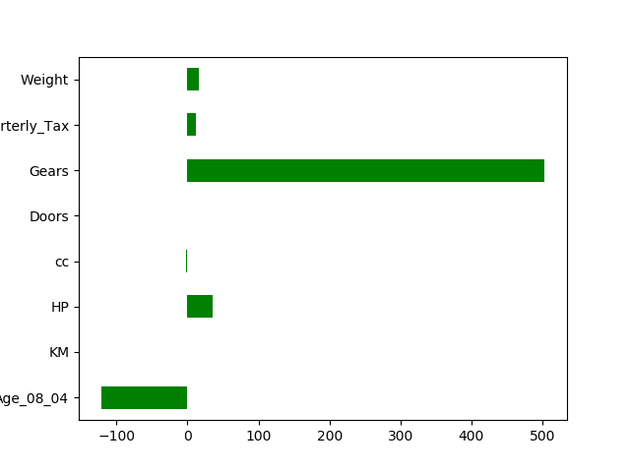

**Building Elastic Net Model =**

* **Scatter Plot for Selection of Perfect Lambda value : -**

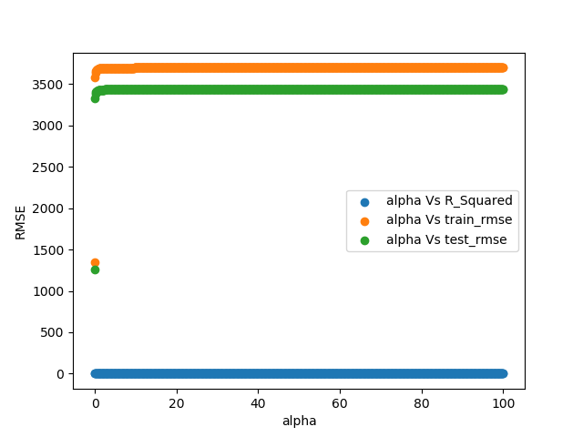

**Accuracy =** Building model by selecting optimum value of Lambda i.e. 0.0001 by help of the above plot. Accuracy given by model as follows.

* **R2 : -** 87%
* **Train RMSE : -** 1348
* **Test RMSE :** - 1262

**Important Coefficient Plot =**

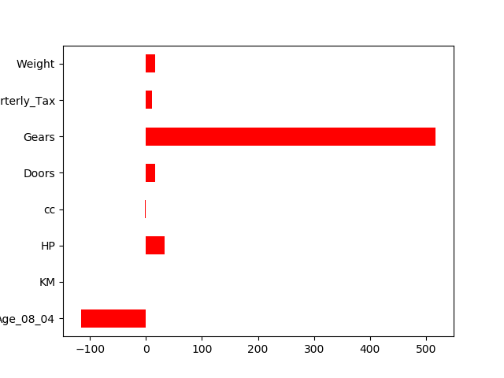

Form Above Three model Lasso or Ridge is giving us best result so we can be use it for future prediction

**Python code file**: - [Toyota Corolla Lasso and Ridge Analysis.py](https://github.com/nilaydeshmukh0/Lasso-Ridge-and-ElasticNet-Regression-With-EDA/blob/master/Toyota%20Corolla%20Lasso%20and%20Ridge%20Analysis/Toyota%20Corolla%20Lasso%20and%20Ridge%20Analysis.py)